Returns and Exchange

Returns/Exchanges
Lucky J Boots and More will gladly accept your returns for exchange or credit within 30 days of purchase. Merchandise must be in as new condition (tags, packaging intact, unworn).
Boots may be exchanged or returned only if the soles are unscratched and the boots are in as –new condition. When trying on boots, be sure to walk only in carpeted areas until you are sure that your boots fits correctly.

Download your return form here

You must include the Merchandise Return Form with your return. Be sure to include a copy of your packing slip, email order confirmation, or a printed copy of your order inside the package. There will be a $15 restocking charge for any returns without an exchange.

Extended Exchanges
Any purchases made between November 20th and December 31st will have until January 31st to make any returns or exchanges.

Shipping
You will be responsible for paying for your own shipping costs for returning your item. Shipping costs are non-refundable.

If you are exchanging an item and a credit is required, your card will be credited for that purchase. A new order will then be placed for a new item. You will see a new authorization for this new order.
If you are to receive credit on your credit card, allow one to two billing cycles for the credit to appear on your statement. If there is additional amount owed, your credit card will be charged for any replacement merchandise when shipped.

If you have any questions, regarding your order please Contact us at lucky@ecarthage.com
Thanks for shopping at Lucky J Boots and More!

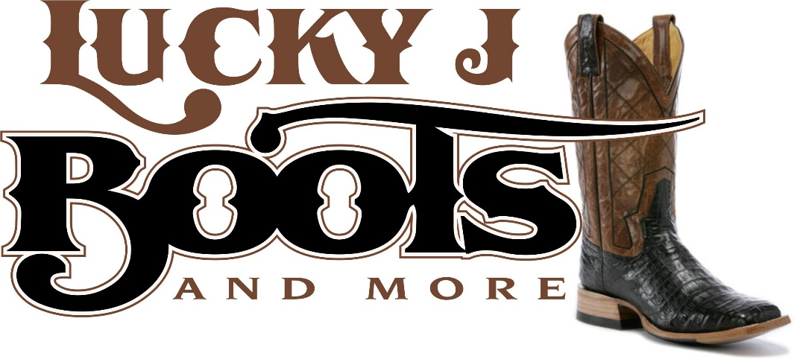
Merchandise Return Form

Original Order Date:_____________Order Number:__________________Date of Return:______________
Name:________________________________________________________________________________
Address:______________________________________________________________________________
City:_________________________________________________________________________________
Phone Number:_________________________Email Address:___________________________________
Reason for return (code) Item QTY Refund
____________ _____________________ _____
____________ _____________________ _____
____________ _____________________ _____
____________ _____________________ _____
Return reasons codes: 1-Defective 2-Damaged 3-Wrong size 4-Wrong item 5-Other

Exchange for : Item (Name)______________________Color:_______Size:_______Qty:________

Exchange for: Item (Name)______________________Color:________Size:_______Qty:________

Exchange for: Item (Name)______________________Color:________Size:_______Qty:________

Lucky J Boots and More/LuckyJArena.com will gladly accept your returns for exchange or credit within 30 days of the purchase. Merchandise must be in as-new condition (tags, packaging intact, unwashed, unworn).
Send to: Lucky J Boots and More
11664 E Fir Rd
Carthage, MO 64836

